# A

## PROJECT REPORT

ON

### ATHLETE’S CLUB MANAGEMENT

Submitted in partial fulfillment for the award of

**Post Graduate Diploma in Advance Computing**

# (PG-DAC) from

### INSTITUTE OF EMERGING TECHNOLOGIES

**Authorized Training Centre**



### Under the Guidance of Mr. Saleel Bagde

### BY

**Name of student’s PRN**

|  |  |
| --- | --- |
| **1. Apeksha Anil Kamble** | **230345920018** |
| **2. Jayant Mohan Uttarwar** | **230345920039** |
| **3. Tejas Prakash Patil** | **230345920108** |
| **4. Vivek Bharat Londhe** | **230345920110** |



# CERTIFICATE

This is to certify that the project report entitled **ATHLETE’S CLUB MANAGEMENT** is a bonfire work carried out by

**1.Apeksha Anil Kamble 2. Jayant Mohan Uttarwar** **3. Tejas Prakash Patil 4. Vivek Bharat Londhe** submitted in partial fulfillment of the requirement for the C-DAC ACTS, DAC course in the Institute of Emerging Technology in the batch of Sept 2022.

**Course Coordinator External Examiner**

**ACKNOWLEDGEMENT**

This project **ATHLETE’S CLUB MANAGEMENT** was a great learning experience for us and we are submitting this work to Advanced Computing Training School (CDAC).

We are very glad to mention Mrs. Prachi Godbole for her valuable guidance to work on this project. Her guidance and support helped us to overcome various obstacles and intricacies during the course of project work.

Our most heart full thanks goes to ***Mr. Sangram Patil* (Director, IET)** who gave all the required support and kind coordination to provide all the necessities like required hardware , internet facility and extra lab hours to complete the project and throughout the course up to the last day here in C-DAC ACTS, Pune.

|  |  |  |  |
| --- | --- | --- | --- |
| **Sr.No.** | **Name** | **PRN** | **Sign** |
| 1. | Apeksha Anil Kamble | 230345920018 |  |
| 2. | Jayant Mohan Uttarwar | 230345920039 |  |
| 3. | Tejas Prakash Patil | 230345920108 |  |
| 4. | Vivek Bharat Londhe | 230345920110 |  |

**INDEX**

|  |  |  |
| --- | --- | --- |
| **Sr. No.** | **Title** | **Page No.** |
| **1** | Introduction | 5 |
| **1.1** | Purpose | 5 |
| **1.2** | Need of System | 7 |
| **1.3** | Overview | 8 |
| **2** | Problem Definition and Scope | 10 |
| **3** | Requirements | 12 |
| **3.1** | Functional Requirement | 12 |
| **3.1.1** | User Account | 12 |
| **3.1.2** | Registration and creation of user profile | 13 |
| **3.1.3** | Trainer Account | 13 |
| **3.1.4** | Admin Account | 14 |
| **3.2.1** | Quick Search | 15 |
| **4** | Design | 16 |
| **4.1** | Database Design | 16 |
| **5** | Coding Standards Implemented | 18 |
| **6** | Test Report | 19 |
| **7** | Entity Relationship Diagram | 20 |
| **8** | Class Diagram | 20 |
| **9** | Use Case Diagram | 21 |
| **10** | Screen Shots | 21-28 |
| **11** | Refrences | 29 |

# INTRODUCTION TO PROJECT

Gyms are the essential part of our lives, providing best exercise and body building facilities to our society. Therefore, at the management end there are some necessary steps to maintain the records of every individual including trainer, gym members, and admin but maintaining the records on paper is very difficult. So it is necessary to have a computerized system that manages all these functionality. Thus working on the management system for Gym Industry is the basis of our project.

The web based “Athlete’s Club Management System” project is an attempt to simulate basic concepts of Athlete’s Club Management system. The system enables the member to do the things such as search for workout-plans, diet plans and choose them based on the details of the plans.

The system provides a facility that provides details about gym contact details with locations, Gallery, Programs and Blogs. But if user wants to book plan then he/she must login into his/her account.

The system allows the gym-members to search for subscription-plans, workout-plans and diet-plans which are provided by the management. The system displays all the plan’s details such as plan-Id, plan- Name, duration and amount. Services provided by Gym are also handled by this system.

**1.1 PURPOSE**

The purpose of Athlete’s Club Management is to facilitate the efficient and effective operation of a fitness facility while creating a positive experience for both members and staff. This encompasses a variety of objectives and goals that collectively contribute to the success and sustainability of the gym. The primary purposes of Athlete’s Club Management include:

**Member Satisfaction:** Creating an environment where gym members feel motivated, comfortable, and supported in their fitness journeys, leading to increased member retention and positive word-of-mouth referrals.

**Health and Wellness Promotion:** Offering fitness programs, classes, and services that contribute to the physical health, mental well-being, and overall wellness of the members.

**Operational Efficiency:** Streamlining day-to-day operations, facility maintenance, equipment management, and staff scheduling to ensure smooth functioning and optimal resource utilization.

**Staff Management:** Recruiting, training, and supervising qualified fitness trainers, instructors, administrative staff, and support personnel to deliver excellent customer service and expertise.

**Membership Growth:** Developing marketing strategies, promotional campaigns, and referral programs to attract new members and expand the gym's client base.

**Financial Sustainability:** Managing finances, including budgeting, revenue tracking, expense control, and pricing strategies, to ensure the gym remains profitable and financially stable.

**Program Variety:** Designing and offering a diverse range of fitness programs, classes, and training options that cater to different fitness levels, interests, and goals.

**Personalized Fitness:** Providing personalized fitness plans, one-on-one training sessions, and expert guidance to help members achieve their individual fitness objectives.

**Member Engagement:** Organizing engaging events, challenges, workshops, and community-building activities that foster a sense of belonging and motivation among members.

**Technology Integration:** Incorporating Athlete’s Club Management software, online booking systems, and fitness tracking apps to enhance member experience and streamline administrative tasks.

**Data-Driven Decisions:** Collecting and analyzing data related to member preferences, attendance, program effectiveness, and financial performance to make informed decisions.

**Regulatory Compliance:** Adhering to industry regulations, safety standards, health guidelines, and legal requirements to ensure a safe and legally compliant gym environment.

**Continuous Improvement:** Gathering feedback from members and staff to identify areas for improvement and implementing changes that enhance the gym experience.

**Community Impact:** Contributing positively to the local community by promoting fitness, health awareness, and community involvement through the gym's initiatives.

**Long-Term Success:** Establishing a strategic vision, setting goals, and planning for the gym's growth and development over the long term.

Overall, the purpose of Athlete’s Club Management is to create a well-rounded, member-centric fitness facility that not only helps individuals achieve their fitness goals but also operates as a thriving business entity that benefits both its members and the broader community.

**1.2 NEED OF SYSTEM**

The need for a comprehensive Athlete’s Club Management system arises from the complexity and multifaceted nature of running a fitness facility. Such a system helps streamline operations, enhance member experience, optimize resources, and ensure the overall success of the gym. Here are some reasons highlighting the need for a system of Athlete’s Club Management:

**Efficient Operations:** A management system streamlines administrative tasks, schedules, and resource allocation, leading to smoother day-to-day operations and reduced operational inefficiencies.

**Member Experience:** Providing a seamless and user-friendly experience for members, from class bookings and payments to personalized fitness plans and progress tracking.

**Staff Management:** Effectively managing staff scheduling, training, and performance tracking to ensure that the gym operates with qualified and motivated personnel.

**Membership Management:** Handling member registrations, renewals, cancellations, and payments accurately and efficiently.

**Personalized Fitness:** Offering customized fitness plans and training regimens that cater to individual member goals and needs.

**Class and Program Management:** Managing class schedules, registrations, and attendance tracking for various fitness programs and classes.

**Financial Tracking:** Monitoring the gym's financial health by tracking revenue, expenses, and memberships, and generating financial reports.

**Membership Engagement:** Utilizing communication tools to engage with members, provide updates, and promote events and offers.

**Resource Optimization:** Efficiently managing equipment usage, facility space, and other resources to maximize utilization and minimize downtime.

**Reporting and Analytics:** Generating reports and analyzing data related to membership trends, class attendance, revenue streams, and more to make informed decisions.

**Marketing and Promotion:** Implementing marketing strategies, managing promotional campaigns, and tracking their effectiveness to attract and retain members.

**Health and Safety Compliance:** Ensuring adherence to safety protocols, health regulations, and industry standards to provide a safe workout environment.

**Data Security:** Safeguarding member information, financial data, and sensitive information through secure data management practices.

**Integration with Technology:** Integrating Athlete’s Club Management software, mobile apps, and online platforms to enhance member engagement and convenience.

**Inventory Management:** Keeping track of inventory, supplies, and equipment maintenance to ensure a well-equipped and functional gym environment.

**Membership Retention:** Implementing strategies to enhance member retention through exceptional services, engaging programs, and personalized interactions.

**Community Building:** Organizing events, challenges, and activities that foster a sense of community among gym members.

**Streamlined Communication:** Providing a centralized platform for member-staff communication, inquiries, and issue resolution.

**Regulatory Compliance:** Ensuring compliance with legal and regulatory requirements specific to the fitness industry.

**Long-Term Planning:** Supporting strategic planning, goal setting, and growth initiatives for the gym's continued success.

In summary, a well-implemented Athlete’s Club Management system enhances operational efficiency, member experience, and business growth. It helps create a cohesive and organized environment that benefits both gym staff and members, ultimately contributing to the overall success of the fitness facility.

* 1. **OVERVIEW**

Athlete’s Club Management refers to the systematic administration, organization, and coordination of all aspects related to running a fitness facility. It involves a combination of administrative tasks, operational logistics, member services, and strategic planning to ensure the gym's success, member satisfaction, and overall effectiveness. A well-implemented Athlete’s Club Management system encompasses various components, functions, and considerations, all aimed at creating a thriving fitness environment. Here's an overview of key aspects related to Athlete’s Club Management:

**Administrative Functions:**

**Membership Management:** Handling member registrations, renewals, cancellations, and payments. Keeping accurate membership records.

***Staff Management:*** Recruiting, training, scheduling, and supervising fitness trainers, instructors, administrative staff, and maintenance personnel.

***Financial Management:*** Tracking revenue streams, managing expenses, budgeting, and generating financial reports to ensure the gym's financial health.

***Inventory Control:*** Managing gym equipment, supplies, and maintenance schedules to keep the facility well-equipped and functional.

***Scheduling:*** Creating and managing class schedules, trainer availability, and facility usage to optimize resource allocation.

**Member-Centric Services:**

***Personalized Fitness Plans:*** Offering tailored workout routines and nutrition guidance based on individual member goals and fitness levels.

***Class Management:*** Providing a variety of fitness classes, workshops, and training sessions to cater to different preferences and needs.

***Progress Tracking:*** Allowing members to track their fitness progress, set goals, and monitor improvements over time.

***Communication Channels:*** Facilitating member-staff communication through online platforms, mobile apps, and direct interactions.

**Operational Efficiency:**

***Facility Maintenance:*** Ensuring a clean, safe, and well-maintained workout environment through regular cleaning and equipment upkeep.

***Resource Utilization:*** Managing equipment availability, facility space, and staff schedules to maximize efficient resource utilization.

***Technology Integration:*** Incorporating Athlete’s Club Management software, member portals, online booking systems, and fitness tracking apps.

**Marketing and Engagement:**

***Member Engagement:*** Organizing challenges, events, social gatherings, and community-building activities to foster member engagement.

***Marketing Strategies:*** Designing and implementing marketing campaigns, promotions, and referral programs to attract and retain members.

***Branding:*** Creating a strong gym brand identity through consistent visual elements, values, and messaging.

**Compliance and Safety:**

***Health and Safety:*** Adhering to safety regulations, health guidelines, and sanitation practices to ensure member well-being.

***Legal Compliance:*** Abiding by industry regulations, contractual obligations, and legal requirements relevant to fitness facilities.

**Long-Term Planning and Growth:**

***Strategic Vision:*** Setting long-term goals, planning for expansion, and envisioning the gym's growth trajectory.

***Data-Driven Decisions:*** Utilizing data and analytics to make informed decisions about programs, services, and operational improvements.

In essence, Athlete’s Club Management involves a multifaceted approach that combines business acumen, member-centric services, operational efficiency, and strategic planning to create a well-functioning and successful fitness facility. A cohesive Athlete’s Club Management system ensures that the gym not only attracts and retains members but also contributes positively to their health and wellness journey.

**2.PROBLEM DEFINITION AND SCOPE**

**PROBLEM DEFINITION**

Athlete’s Club Management refers to the systematic coordination, organization, and oversight of all operational, administrative, and customer-oriented aspects within a fitness facility. It involves the strategic planning, implementation, and supervision of various functions to ensure the smooth operation of the gym, the delivery of high-quality fitness services, and the achievement of both member satisfaction and business goals.

**SCOPE**

The scope of Athlete’s Club Management covers a wide range of activities and responsibilities that are involved in operating and maintaining a successful fitness facility. This includes various aspects related to administration, customer service, fitness programs, facilities management, marketing, and more. Here's an overview of the scope of Athlete’s Club Management:

**Facility Management:**

Ensuring the cleanliness, safety, and functionality of the gym space and equipment.

Overseeing maintenance and repairs of gym equipment and facilities.

Managing the layout and organization of the gym to optimize space usage.

**Membership Management:**

Handling membership registrations, renewals, cancellations, and inquiries.

Maintaining accurate member databases and records.

Implementing access control systems for member entry.

**Staff Management:**

Hiring, training, and supervising fitness trainers, instructors, front desk staff and maintenance personnel.

Scheduling shifts, classes, and personal training sessions.

Ensuring staff deliver excellent customer service and adhere to gym policies.

**Fitness Programs and Services:**

Designing and offering a variety of fitness programs, classes, and workshops.

Providing personal training and customized workout plans for members.

Incorporating trends and new fitness techniques into program offerings.

**Health and Safety:**

Implementing safety protocols to prevent accidents and injuries within the gym.

Providing first aid and emergency response procedures.

Promoting proper hygiene and cleanliness standards.

**Marketing and Promotion:**

Developing marketing strategies to attract new members and retain existing ones.

Creating promotional campaigns, special offers, and referral programs.

Managing the gym's online presence through social media, website, and online advertising.

**Financial Management:**

Budgeting and financial planning to ensure the gym's profitability.

Managing revenue streams, membership fees, and ancillary services.

Tracking expenses, payroll, and other financial transactions.

**Member Engagement:**

Organizing events, challenges, and competitions to keep members engaged and motivated.

Collecting and responding to member feedback to improve services.

**Technology Integration:**

Implementing Athlete’s Club Management software for membership tracking, scheduling, and billing.

Introducing virtual training options and online class bookings.

Utilizing wearable fitness technology to monitor member progress.

**Nutrition and Wellness:**

Offering nutritional guidance, diet plans, and counseling.

Collaborating with nutritionists or dietitians to provide comprehensive wellness support.

**Compliance and Regulations:**

Ensuring compliance with health and safety regulations in the fitness industry.

Adhering to legal requirements related to business operations and customer data protection.

**Community Involvement:**

Engaging with the local community through fitness events, workshops, and partnerships.

Supporting charitable initiatives or wellness programs.

**Continuous Improvement:**

Analyzing gym performance metrics to identify areas for improvement.

Updating fitness programs and services based on trends and member preferences.

The scope of Athlete’s Club Management is broad and dynamic, requiring a combination of administrative, customer service, fitness expertise, and business skills to create an environment where members can achieve their fitness goals while enjoying a positive and motivating experience.

**3.REQUIREMENTS**

**3.1 FUNCTIONAL REQUIREMENTS**

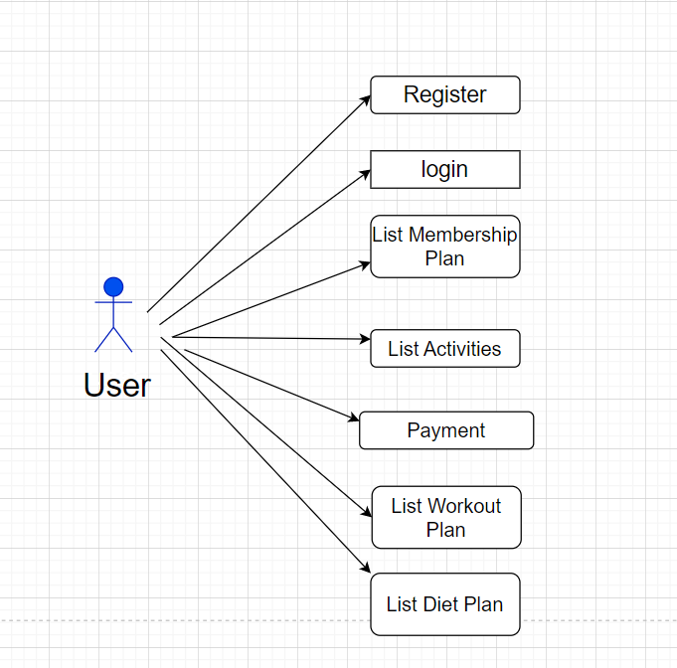

**3.1.1 User Account**

First user has to fill the details using ‘sign up’ function. In this form user has been asked to fill their name, address, email id, contact and password, joining date will be automatically selected, and also there will be option to choose membership where various memberships are present called regular, gold, silver and diamond etc. according to that user has to select plan.

The Athlete’s Club Management System then activates the login form. Here the user enters the User name and password and our system starts the authentication process in which the username and password are matched with the existing username and password in the database.

If the password matches then it is allowed to the ‘sign in’ page else it will give

Alert to user as Invalid User name or password. After successful authentication the system activates menus.

**3.1.2 Registration and creation of user profile**

The system shall require a user to register, in order to access further functionality. It will ask the user for the information such as name, password, address, contact number and email address.

Existing user can directly login from sign in page by providing email id and password. After successful login user can see plans provided by management and select one plan from list while filling the ‘membership form’, activated plan details are visible in My orders section.

A new user, on the other hand, would either have to register himself with the tem by providing personal information without providing personal details user cannot access any of facility which is provided by the gym.

. 

* + 1. **Trainer Account**

To create trainer first we need to login from admin account. Admin has to fill the details using ‘add user’ function. In this form admin needs to fill their name, address, email id, contact ,password and ‘role as trainer’.

Existing trainer can directly login from sign in page by providing email id and password. Trainer can view his/her own profile.

After successful login trainer can perform add, delete and update on diet-plans table and workout-plans table.

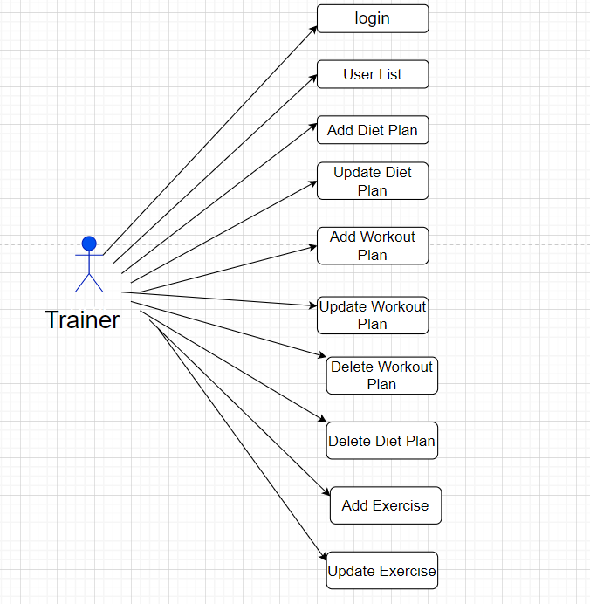

* + 1. **Admin Account**

With the help of the login page admin can login with email-id and password. Admin is the one who runs the gym and has all the permissions to see the member details as well as trainer details and also the promotional materials which are very important part of the gym.

To create trainer first we need to login from admin account because only an existing admin can create another admin. Existing admin can directly login from sign in page by providing email id and password. Admin can view his/her own profile.

An admin can view the user-list which contains all the users who have not subscribed to any plan, trainers and admins as well.

After successful login admin can perform add, delete and update on membership-plans. Admin can also view ‘gym member list’ which includes all the users who have subscribed to a plan.

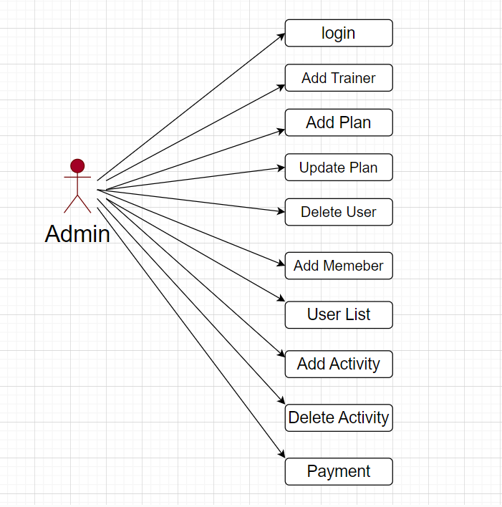

* + 1. **Quick Search**

Here we provided Quick Search facility for any user to search gym facilities without login into account .This will provide user an option for home, gallery, programs, blogs and contacts.

Home page contains basic information about our website and it is the home page for the Athlete’s Club Management System application.

Gallery contains collection of images from our different gym locations. Program contains different types of training provide by our gym and events conducted by management such as blood test etc. It also includes various wellness programs for corporate people as well as individuals.

Blogs contains discussion and information regarding nutrition, health awareness and our gym member’s inspirational stories and experiences. Contact contains different branch details with concern persons information.

**4. DESIGN**

**4.1 Database Design**

The following table structures depict the database design.

# Table1: User

|  |  |  |  |  |
| --- | --- | --- | --- | --- |
| **Key Type/ Constraint** | **Column Name** | **Data Type** | **Length** | **Allow Null (1=Yes;0=No)** |
| PK | User_id | int | 4 | 0 |
|  | Address | Varchar | 255 | 1 |
|  | Contact | Varchar | 255 | 1 |
|  | Email | Varchar | 255 | 1 |
|  | Name | Varchar | 255 | 1 |
|  | Password | Varchar | 255 | 1 |
|  | Role | Varchar | 255 | 1 |

## Table2: Gym member

|  |  |  |  |  |
| --- | --- | --- | --- | --- |
| **Key Type/ Constraint** | **Column Name** | **Data Type** | **Length** | **Allow Null (1=Yes;0=No)** |
| PK | MemberId | int | 4 | 0 |
|  | Gender | Varchar | 255 | 1 |
|  | Height | Double | 4 | 0 |
|  | JoinDate | Date | 10 | 1 |
|  | Weight | Double | 4 | 0 |
| FK | MembershipPlanId | int | 4 | 1 |
| FK | User_id | int | 4 | 1 |
|  | Payment_status | Bit(1) | 1 | 0 |
| FK | Dietplan_Id | int | 4 | 1 |
| FK | Workout_Id | int | 4 | 1 |
| FK | Activity_Id | int | 4 | 1 |

## Table3: Plan

|  |  |  |  |  |
| --- | --- | --- | --- | --- |
| **Key Type/ Constraint** | **Column Name** | **Data Type** | **Length** | **Allow Null (1=Yes;0=No)** |
| PK | SubplanId | int | 4 | 0 |
|  | Amount | int | 4 | 0 |
|  | Duration | int | 4 | 0 |
|  | PlanName | Varchar | 255 | 1 |

## Table4: DietPlan

|  |  |  |  |  |
| --- | --- | --- | --- | --- |
| **Key Type/ Constraint** | **Column Name** | **Data Type** | **Length** | **Allow Null (1=Yes;0=No)** |
| PK | Planid | int | 4 | 0 |
|  | Breakfast | Varchar | 255 | 1 |
|  | Dinner | Varchar | 255 | 1 |
|  | Lunch | Varchar | 255 | 1 |
|  | Planname | Varchar | 255 | 1 |
|  | Preworkout | Varchar | 255 | 1 |

## Table5: WorkoutPlan

|  |  |  |  |  |
| --- | --- | --- | --- | --- |
| **Key Type/ Constraint** | **Column Name** | **Data Type** | **Length** | **Allow Null (1=Yes;0=No)** |
| PK | Workout_Id | int | 4 | 0 |
|  | Set1 | Varchar | 255 | 1 |
|  | Set2 | Varchar | 255 | 1 |
|  | Set3 | Varchar | 255 | 1 |
|  | Workout_Name | Varchar | 255 | 1 |

**E-R Diagram, Use Case diagram and Class Diagram:**

Go to Appendix A

Go to Appendix B

Go to Appendix C

**5. CODING STANDARDS IMPLEMENTED**

Naming and Capitalization

Below summarizes the naming recommendations for identifiers in Pascal casing is used mainly (i.e. capitalize first letter of each word) with camel casing (capitalize each word except for the first one) being used in certain circumstances.

|  |  |  |  |
| --- | --- | --- | --- |
| **Identifier** | **Case** | **Examples** | **Additional Notes** |
| Class | Pascal | Person, BankVault, SMSMessage, Dept | Class names should be based on "objects" or "real things" and should generally be **nouns**. No ‘_’ signs allowed. Do not use type prefixes like ‘C’ for class. |
| Method | Camel | getDetails, updateStore | Methods should use **verbs** or verb phrases. |
| Parameter | Camel | personName, bankCode | Use descriptive parameter names. Parameter names should be descriptive enough that the name of the parameter and its type can be used to determine its meaning in most scenarios. |
| Interface | Pascal with "I" prefix | Disposable | Do not use the ‘_’ sign |
| Property | Pascal | ForeColor, BackColor | Use a noun or noun phrase to name properties. |
| Associated private member variable | _camelCase | _foreColor, _backColor | Use underscore camel casing for the private member variables |
| Exception Class | Pascal with "Exception" suffix | WebException, |  |

### Comments

* Comment each type, each non-public type member, and each region declaration.
* Use end-line comments only on variable declaration lines. End-line comments are comments that follow code on a single line.
* Separate comments from comment delimiters (apostrophe) or // with one space.
* Begin the comment text with an uppercase letter.
* End the comment with a period.
* Explain the code; do not repeat it.

**6. TEST REPORT**

**GENERAL TESTING:**

|  |  |  |  |  |
| --- | --- | --- | --- | --- |
| **SR-NO** | **TEST CASE** | **EXPECTED RESULT** | **ACTUAL RESULT** | **ERROR MESSAGE** |
|  | Register Page | Redirected to Sign in Page | OK | Enter Required Fields |
|  | Sign in Page | Redirected to User UI | Ok | Please enter username and password again. |
|  | Checking login or not | User is logged in or not | Ok | Nothing |
|  | User Created | New user added to list | ok | Nothing |
|  | Find User | User Details Displayed | ok | Nothing |
|  | Find All | User Details Displayed | ok | Nothing |
|  | Membership Plan | All the fields should be filled for submission | Ok | Enter Required Fields |
|  | Health Status | BMI displayed | Ok | Enter Required Fields |
|  | Delete Plan | Plan removed from list | Ok | Nothing |
|  | Add Diet-Plan | All the fields should be filled for submission | Ok | Enter Required Fields |
|  | Update Diet-Plan | Diet-Plan Updated | Ok | Enter Required Fields |
|  | Delete Diet-Plan | Diet-Plan Removed from list | Ok | Nothing |
|  | Add Workout-Plan | All the fields should be filled for submission | Ok | Enter Required Fields |
|  | Update Workout Plan | Workout-Plan Updated | Ok | Enter Required Fields |
|  | Delete Workout-Plan | Workout -Plan Removed from | Ok | Nothing |

Appendix A

7.Entity Relationship Diagram

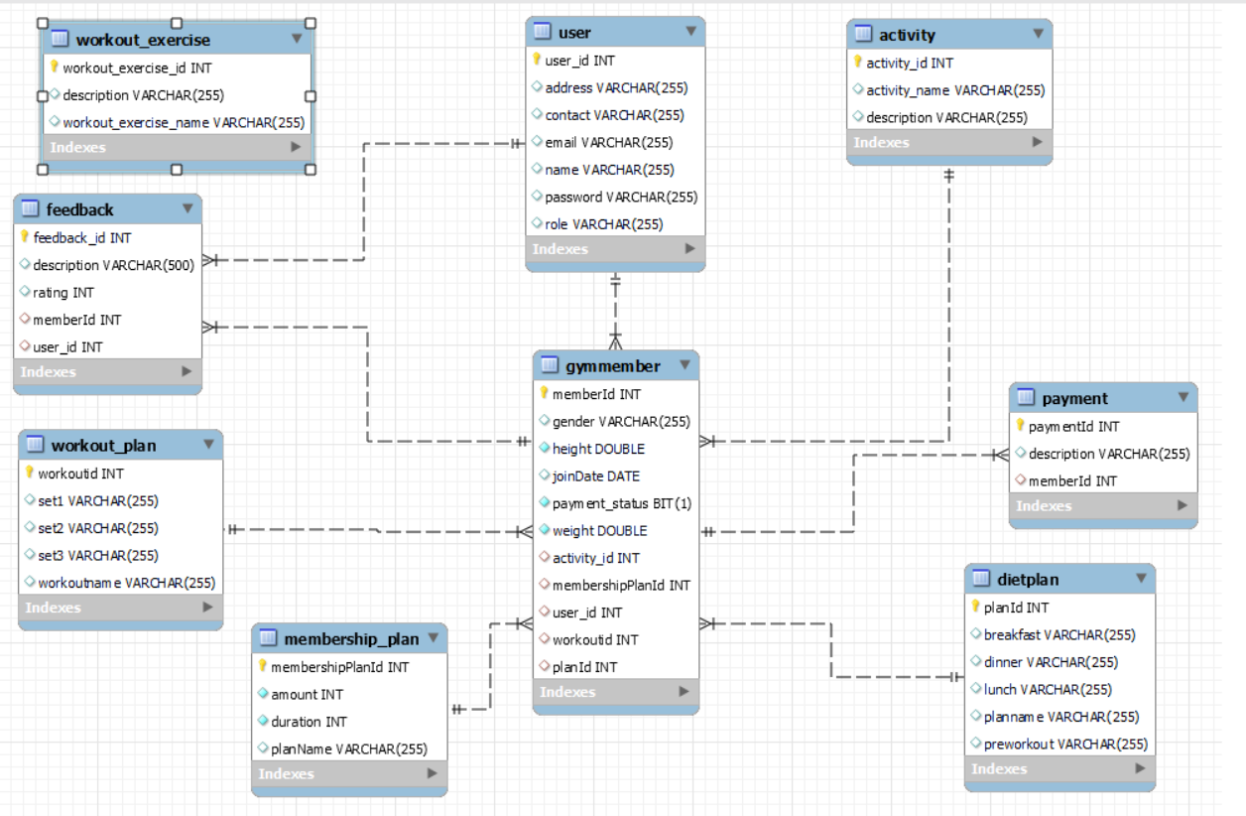

AppendixB

**8.Class Diagram**

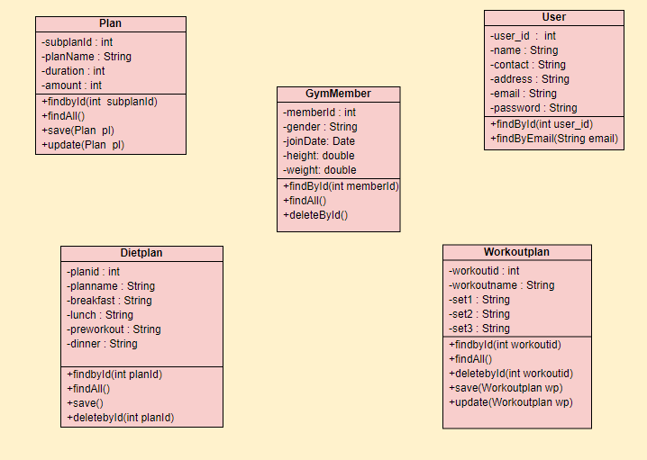

AppendixC

**9.Use Case Diagram**

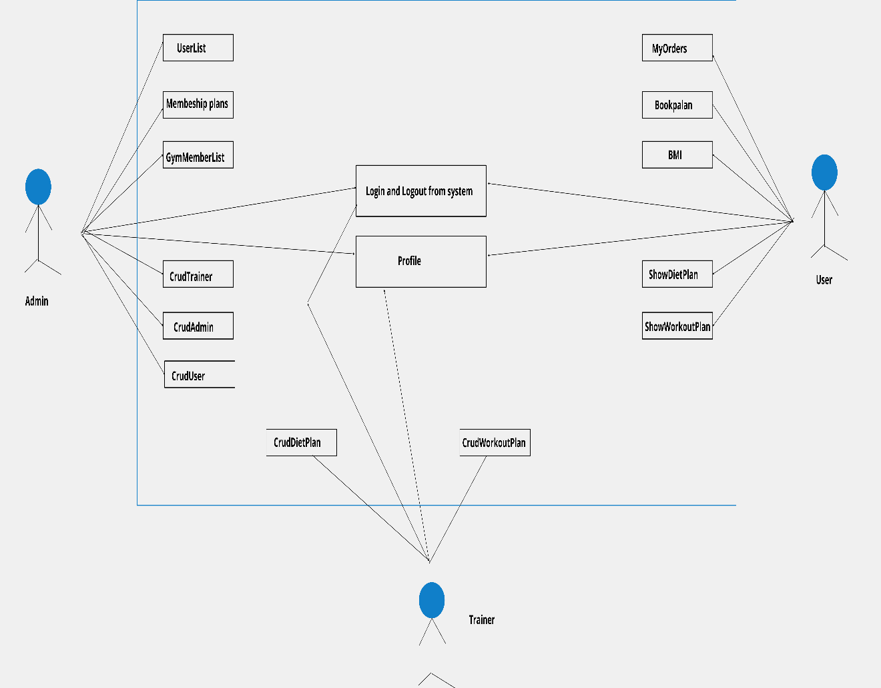

**10.Screen Shots**

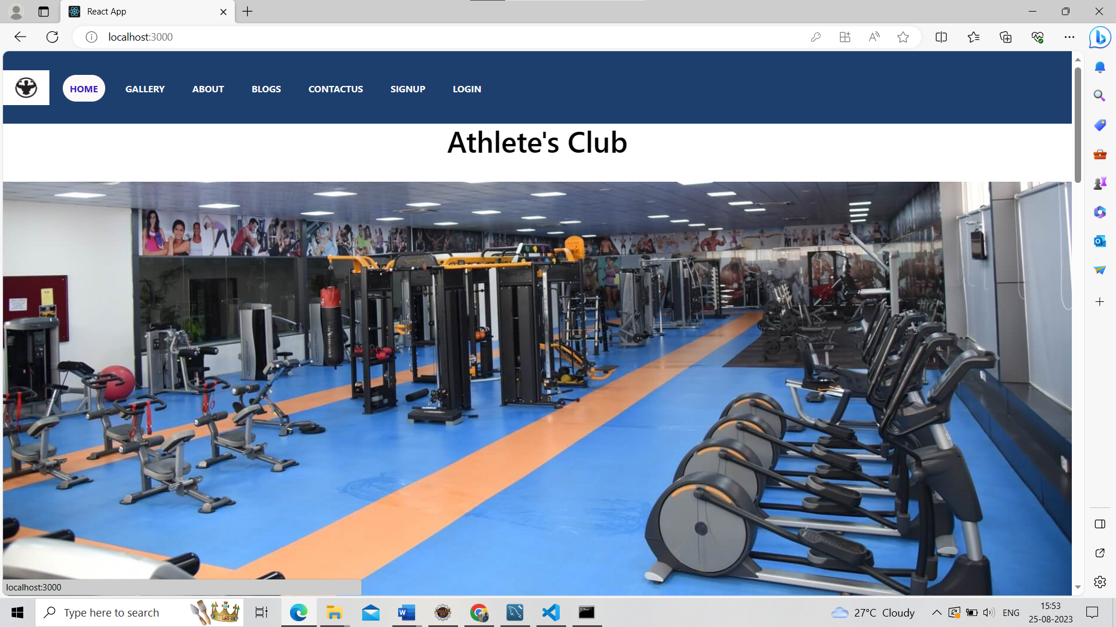

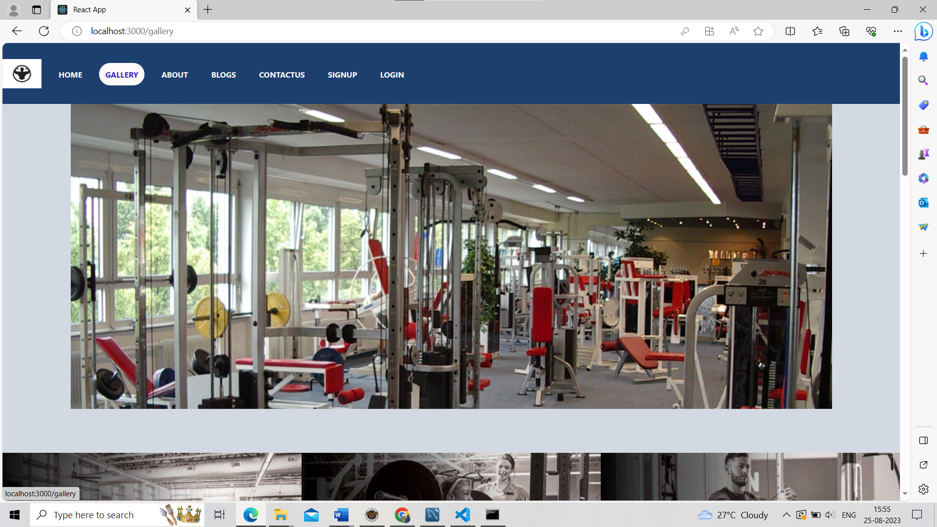

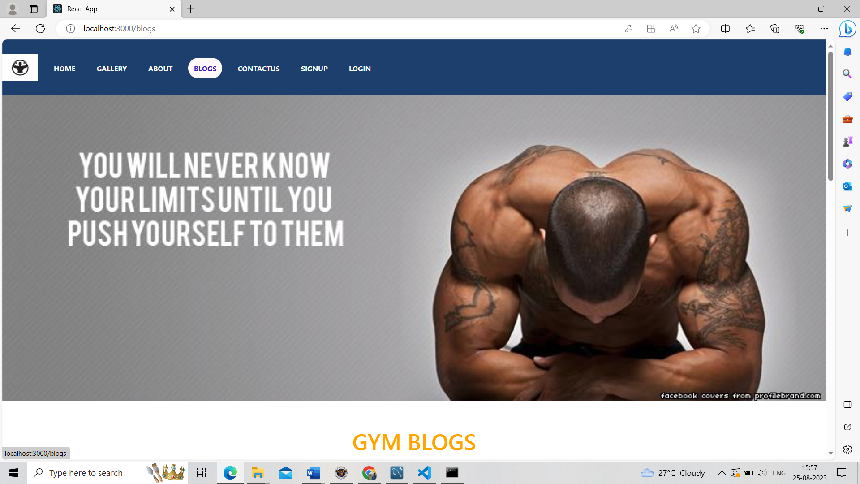

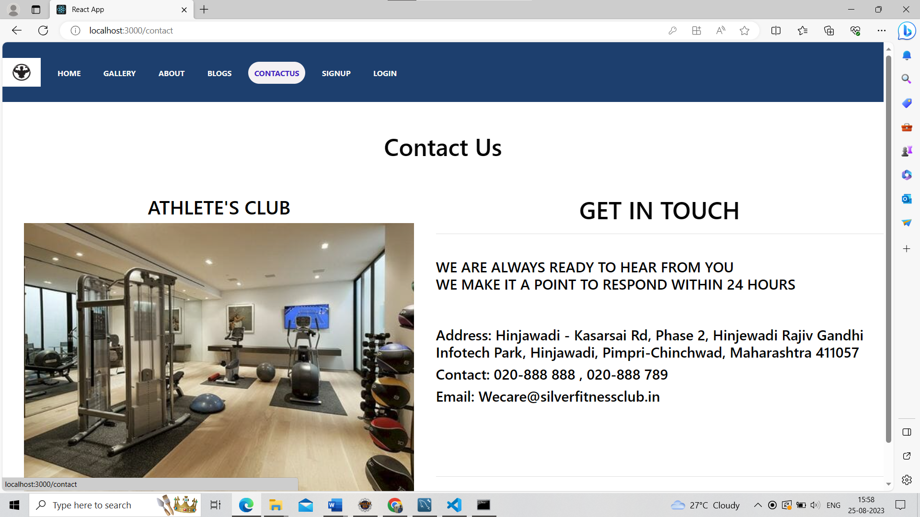

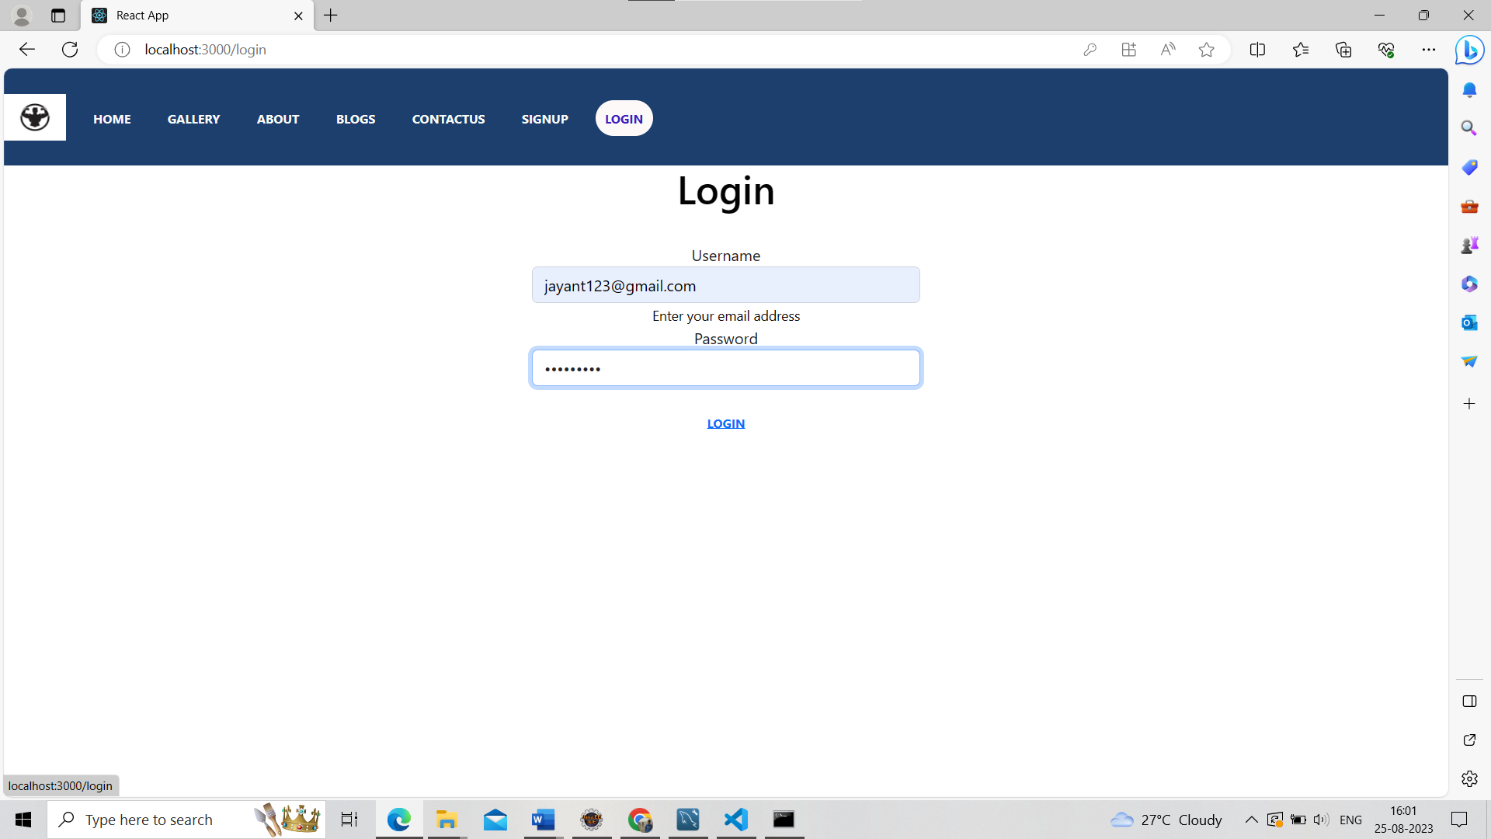

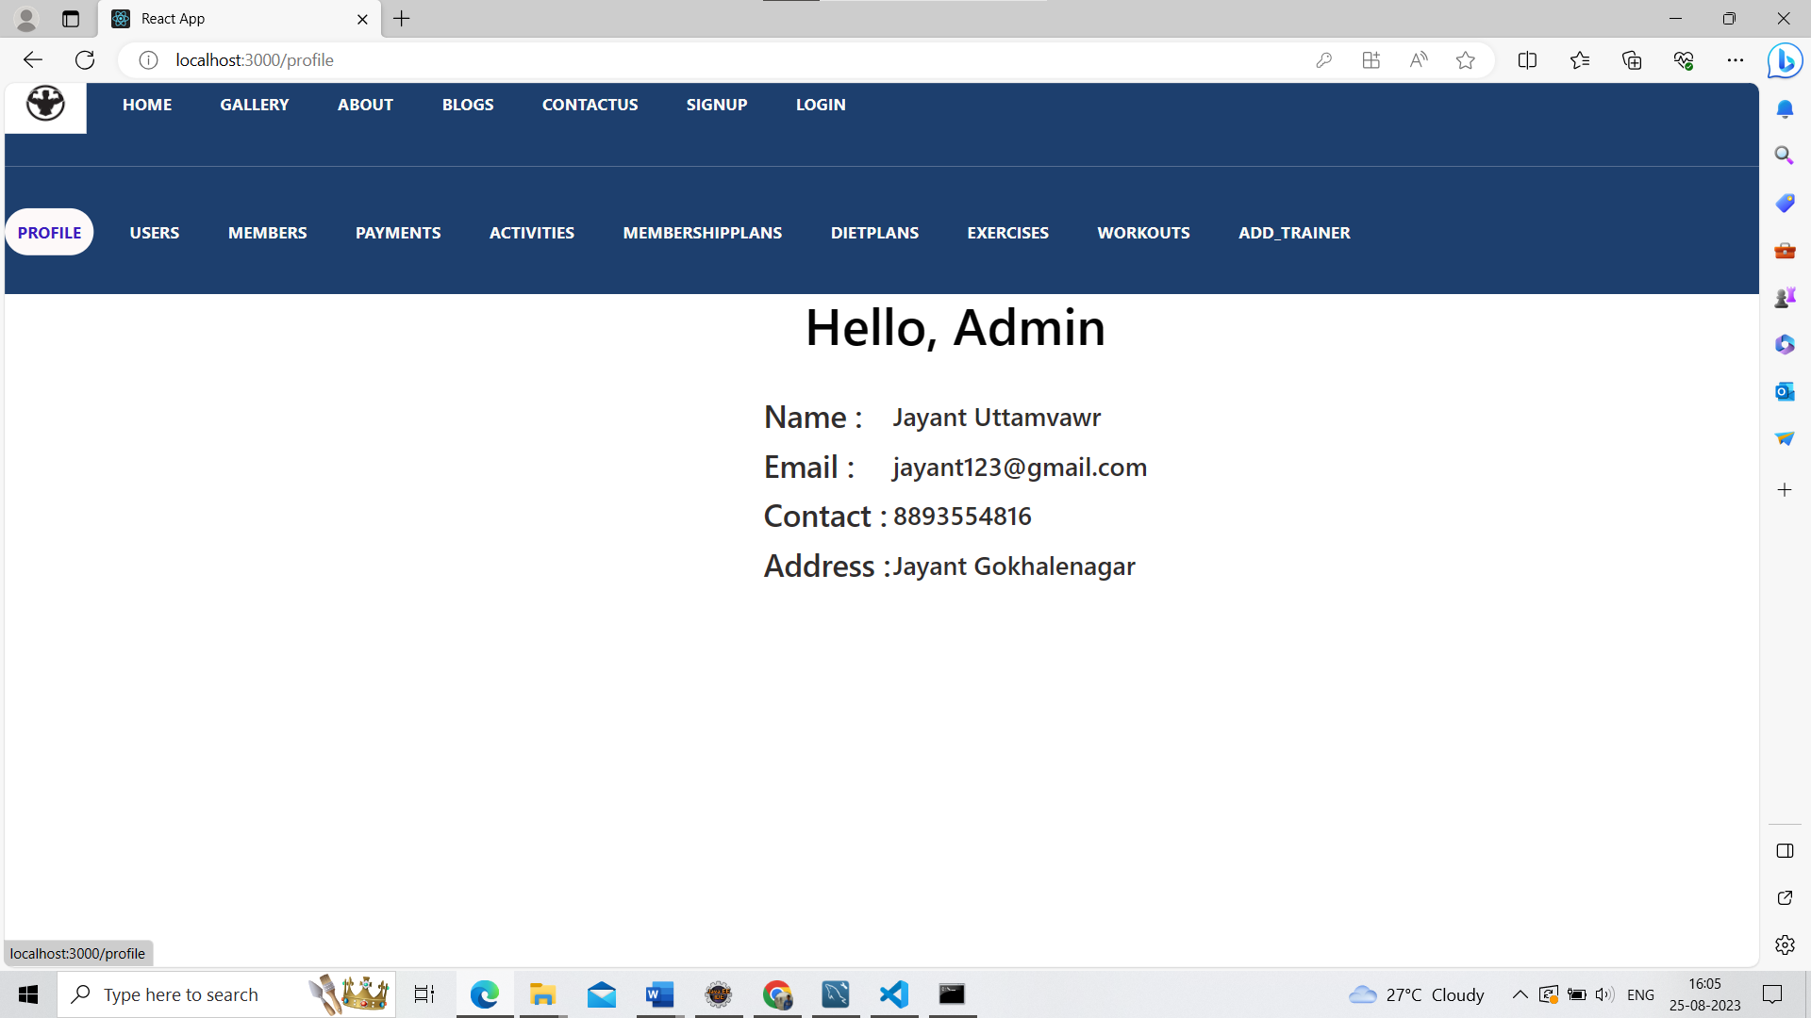

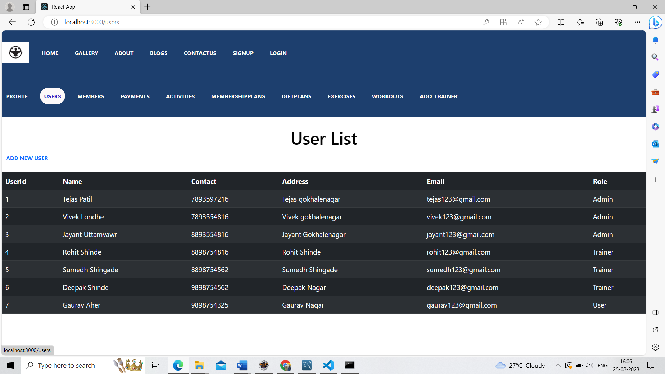

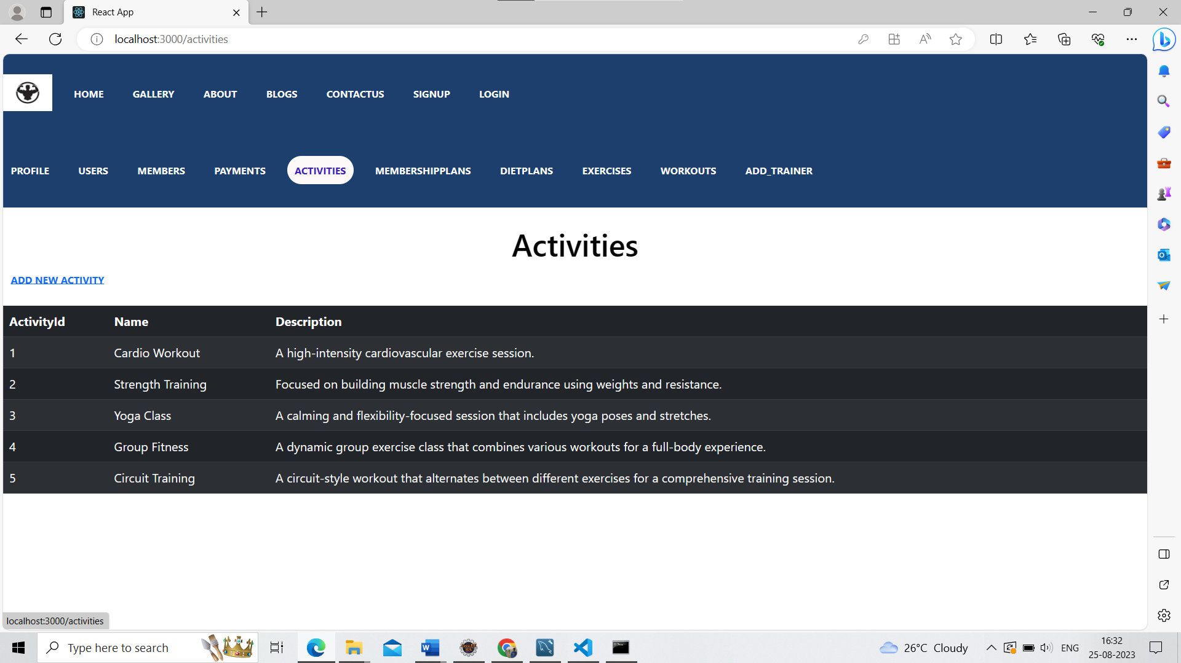

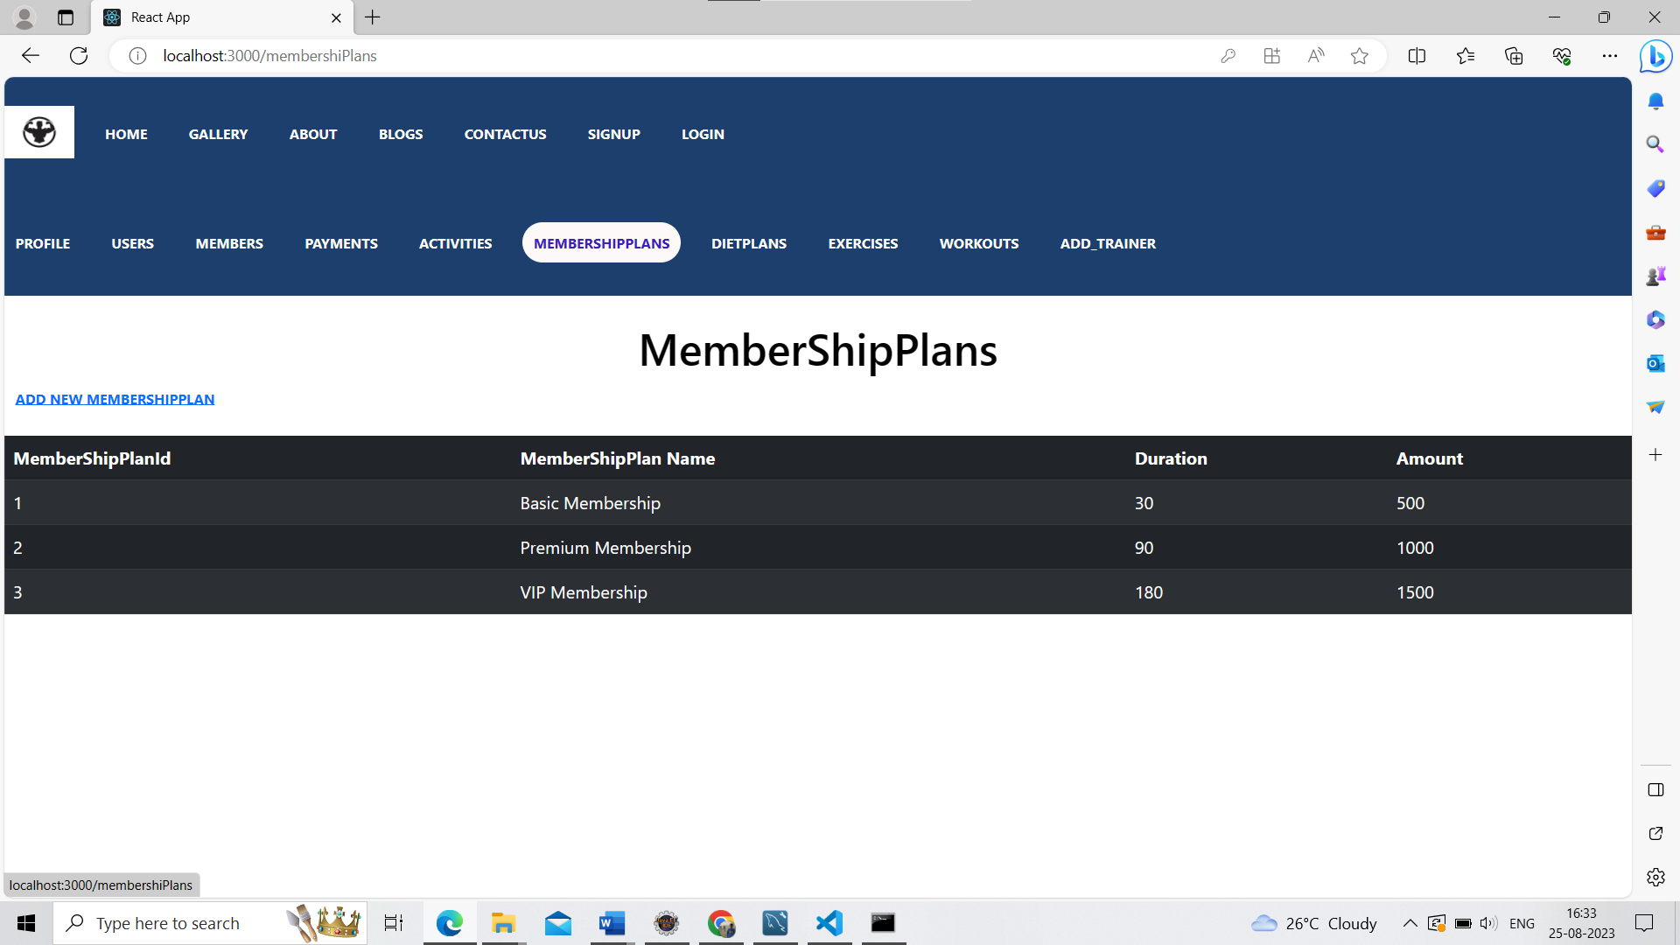

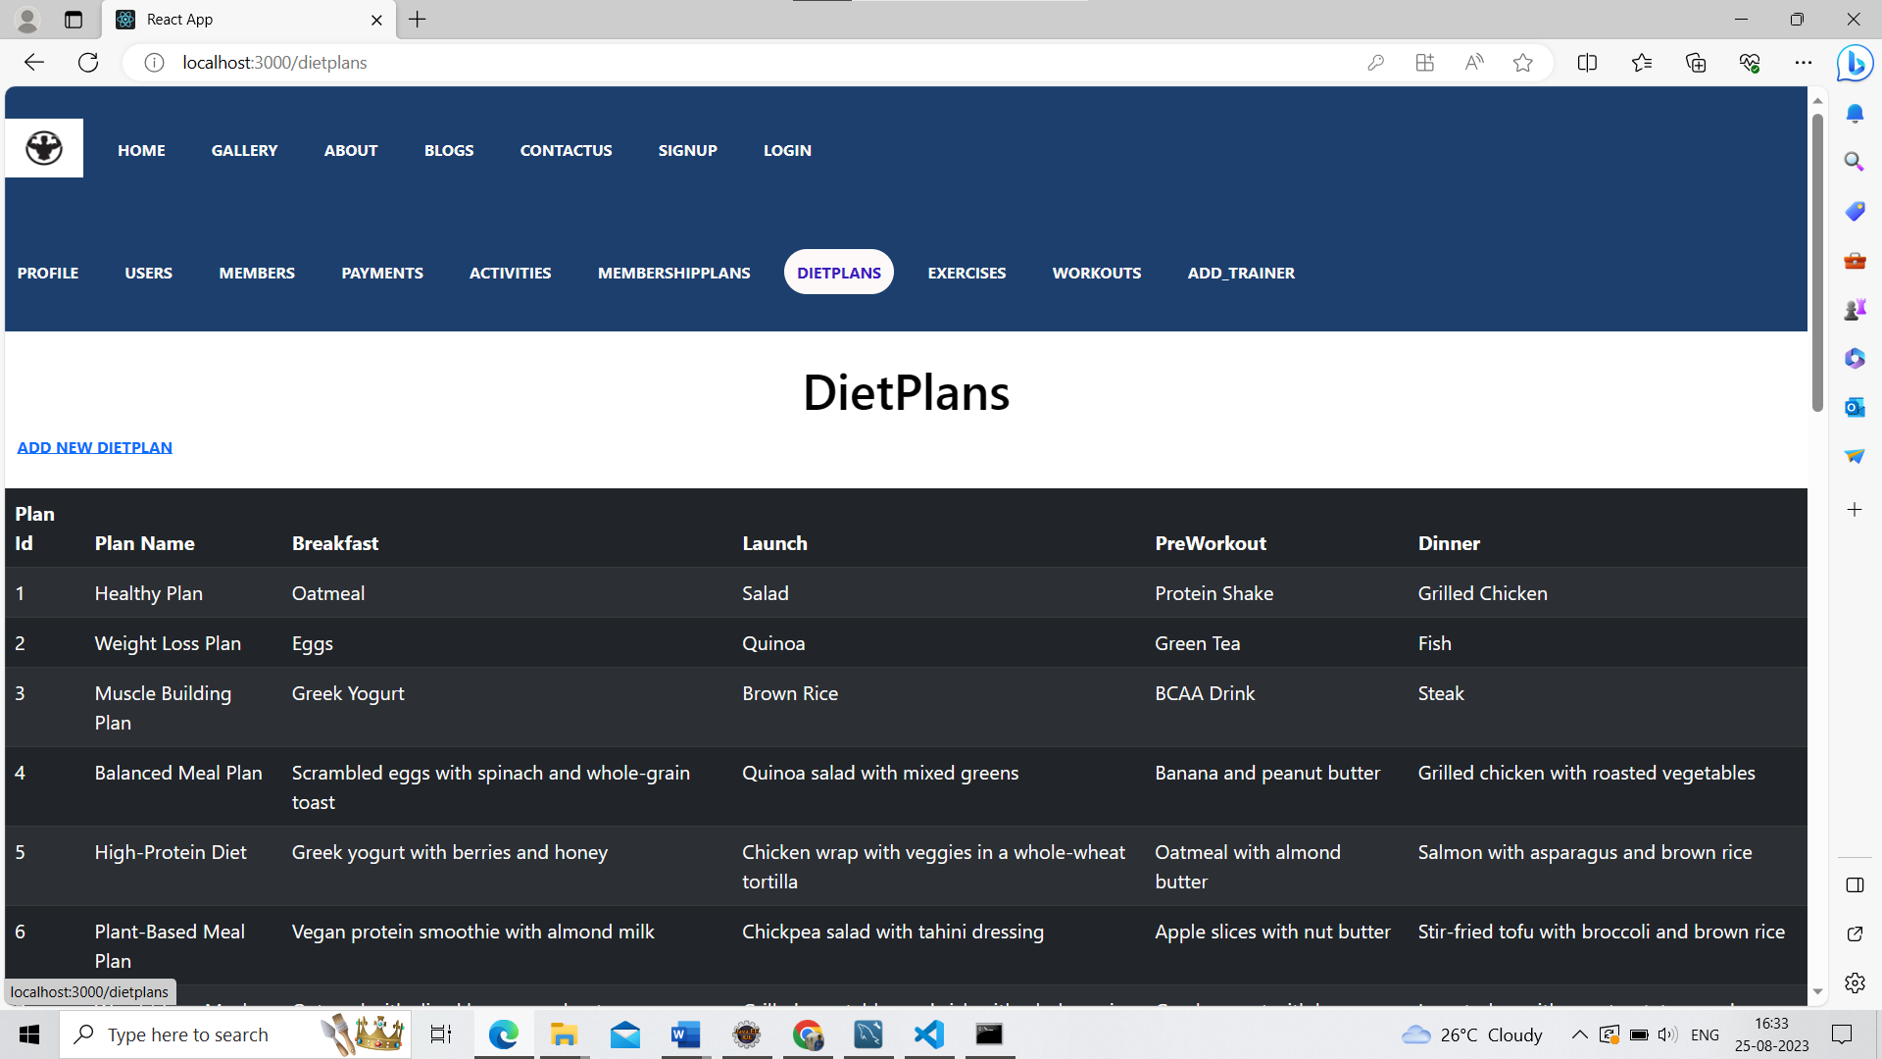

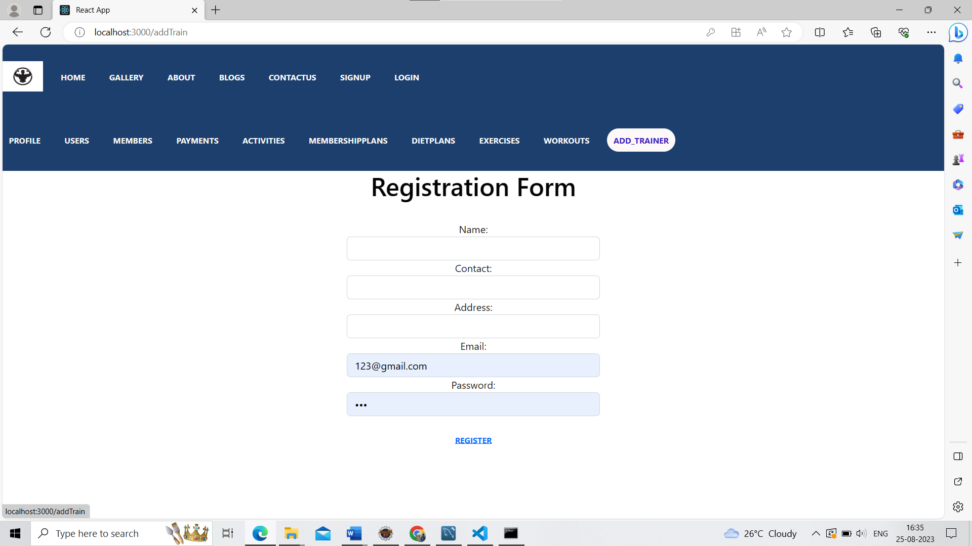

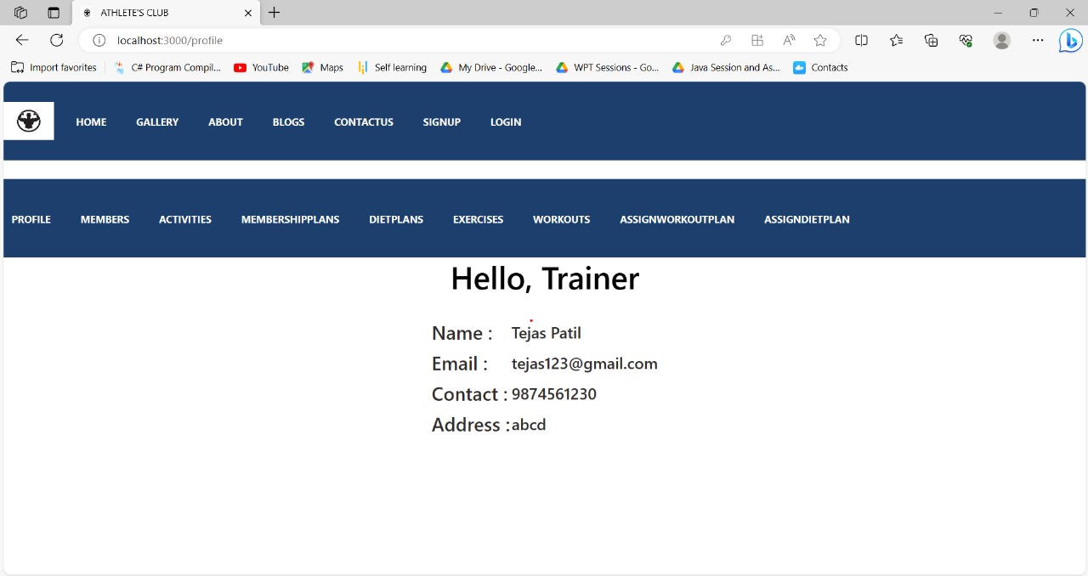

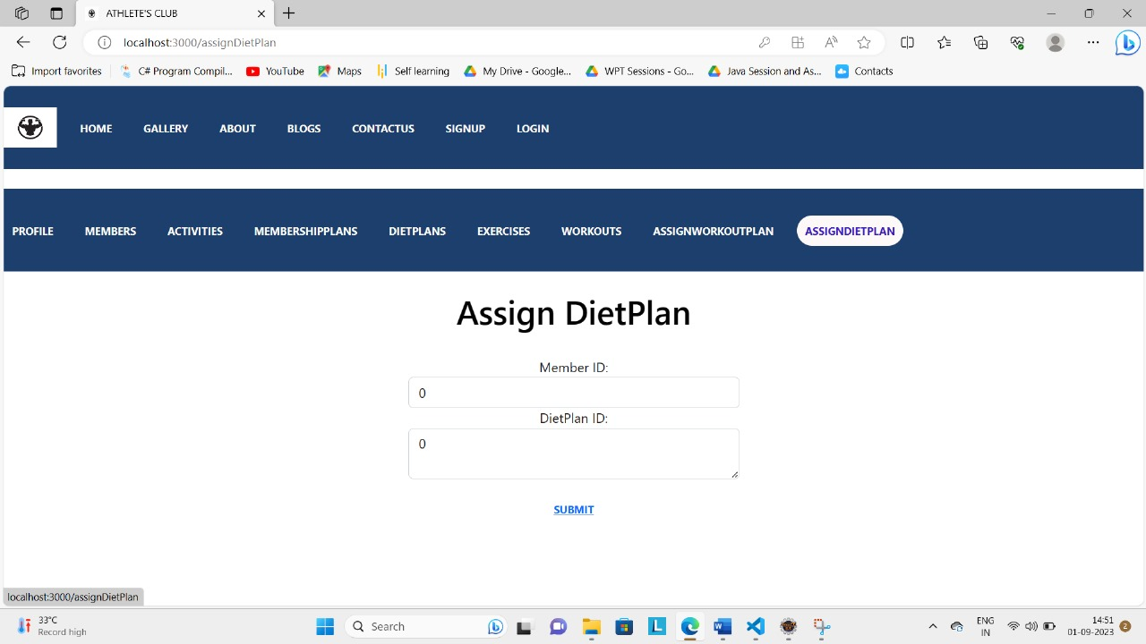

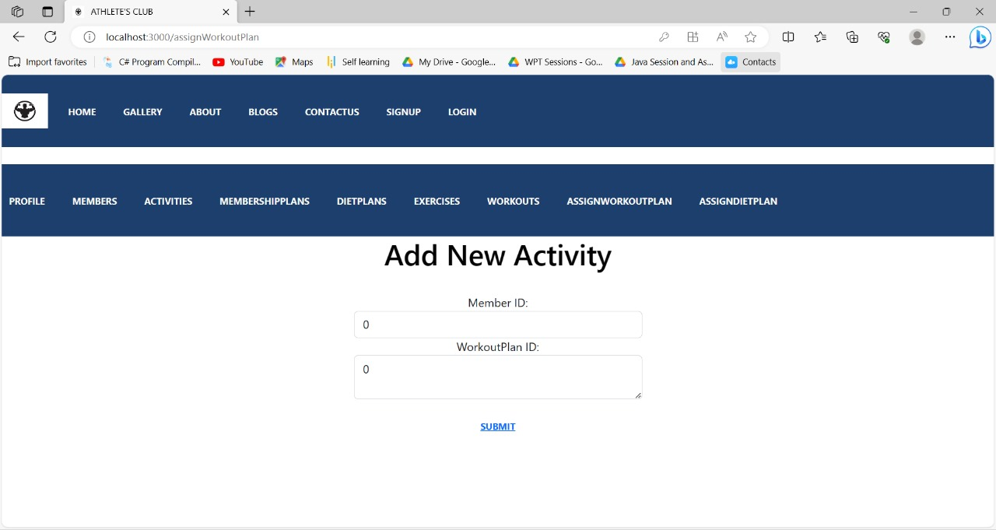

**10.Refrences**

<http://www.google.com>

<https://www.getbootstrap.com>

<https://www.npmjs.com/>

<https://www.goldsgym.in/>

https://www.silverfitnessclub.in/

http://www.w3.org

http://www.wikipedia.org

<http://www.physcgym.com/>